Teen Quizzing Bible Study Method

from http://www.teenbiblequiz.com/home/the-beginners-guide-on-how-to-study-for-bible-quizzing

DAY 1: DOUBLE (OR TRIPLE) REPETITION
This is likely the best method to learn a chapter. As the name implies, each verse is read 2 times (or 3 times for the Triple Repetition method). At every 5th verse, go back and read the previous 5 verses through once and then read through from the beginning once. For best results, read it out loud!
Method:
- Read verse 1, 2, 3, 4, and 5 two (or three) times each.
- Read verses 1-5 through once.
- Read verses 6, 7, 8, 9, and 10 two (or three) times each.
- Read verses 6-10 through once.
- Read verses 1-10 through once.
- Continue until you reach the end of the chapter.

DAY 2: DOUBLE REVIEW
Double Review is best used if you’ve already read the chapter using Double (or Triple) Repetition to reinforce all the key phrases and words for easy recall. Again, for best results read it out loud! Why read it out loud? So you can not only see the words, but hear them:
Method:
- Read verses 1-5 together two times.
- Read verses 6-10 together two times.
- Read verses 1-10 through once.
- Read verses 11-15 together two times.
- Read verses 1-15 through once.
- Continue until you reach the end of the chapter.

DAYS 3 & 4: QUESTION REVIEW
After learning the source material using the reading methods above, test your knowledge by asking yourself questions about the chapter. Use questions provided to you by your quiz coach, download a Bible Quiz app, or print off sample competition questions found on the Study page of this website. Here is one preferred study method:
Cover the answer to the first question of the chapter and try to answer it in your head.
- If Correct: Move on to the next question.
- If Incorrect: Put a check mark next to the question. Look up the verse in the scriptureto be reminded what it says. Read and answer the question again and then proceed to the next question.
When you reach the end of the questions for the chapter, go back and see if you can correctly answer the questions with a check mark. If you miss it again, review the scripture and add another check mark to that question. When you finish the chapter, now try to answer the questions that have 2 check marks. Repeat this process until you have answered all of the questions correctly.

DAY 4: LEARN MEMORY VERSE(S)
Even if you are not a designated “Memory Verse” person, everyone on the team should learn at least one memory verse from each chapter. Choose one (or more) of the proven methods below whether you are learning all of the Memory Verses or just one from each chapter:
- Phrase Repetition – Read through the entire verse once. Now repeat the first phrase (5-10 words or so) of the verse 5 times without looking at it. Say the next phrase 5 times. Now say the first two phrases together once. Say the next phrase 5 times and then the first 3 phrases through once. Continue until the end of the verse. Now say the entire verse perfectly at least 5 times in a row.
- Verse Repetition – Read the verse several times. Now try to say the entire verse without looking at it. Once you can say the entire verse without looking, say it perfectly and as fast as you can 5 times in a row. If you make a mistake, start over with your set of 5.
- Writing Repetition – Simply write each verse enough times to completely cover the front of a piece of notebook paper. Try not to simply copy the verse, but to remember as much as you can each time. When the front of the page is done, try to recite the verse perfectly. If you cannot, continue writing the verse on the back of the paper.
Flash Cards – After learning the verse using any of the 3 methods above, make a color-coded flash card for each of the memory verses. Write the verse on the front of an index card and the reference on the back. Now review all previously-learned memory verses. Put incorrectly-answered cards back into the deck and correctly-answered cards in a different pile. Keep going until your deck of cards is empty.

DAY 5: WRITE QUESTIONS
This exercise will help you learn how to finish a question as well as learn the details of each verse. When writing a question, the easiest thing to do is look for objects of prepositions, nouns, adjectives and adverbs. Be sure your question keeps the same verb-tense and uses as much of the scripture’s language as possible. Start by writing at least one General Knowledge question for every verse in a chapter. As you get better at writing questions, go back and add other types of questions for select verses.

DAY 6: REVIEW (3-5-7 METHOD)
After learning the new material, you need to review old material to keep it fresh in your mind. When reviewing a particular chapter, you should:
- Use the Double Review reading method (See “Day 2” for method)
- Answer several (~20) of the questions you’ve written or missed the most from the question list
When reviewing old material, use the 3-5-7 Method: Review the third chapter back from the current chapter, the fifth chapter back from that chapter and then the seventh chapter back from that chapter. Confused? Here is a chart to guide you:
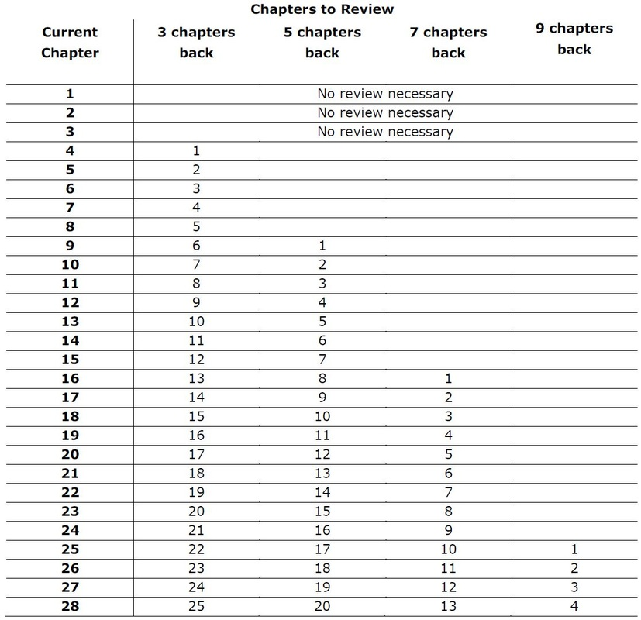

EVERY DAY: LISTEN TO THE SCRIPTURE
For those of you who are auditory learners, get a dramatic reading of the scripture on CD from Amazon or Acme quiz and listen to it while in the car, doing chores or exercising.

